**Social Stuff SoFa Project**

*Social Media privacy, like never seen before.*

Project plan for Social Stuff.   
Contractor:                                  Jörn Neumeyer

Client:

**Company:** Gedak Gmbh

**Location:** Kempen, Germany

**Contact person:** Gerhard Bongardt

**Function:** Founder

Report:

**Title report:**                               Project Management Plan – Social Stuff

**Period:**                                            September 02 2020 – January 15 2021

**Date:**25-09-2020

Management Summary (Dave)

The joint collaboration between: Gedak Gmbh, Social Stuff and the SoFa Fontys students is resulting in to a project sequence. The final goal is providing an implementation of an encrypted chat platform which provides privacy for its users by providing a decentralized structure in which anonymity can be guaranteed.

This project is first in the complete project sequence. This means that we have to do a lot of analysis to understand and determine how the solution will look like. This especially goes for the encryption techniques. The current project sequence is mainly focused on providing a working prototype and providing thorough documentation of said prototype.

As this project’s affinity is very close to some of the Fontys students working on this project, we will have an excellent starting point for us to provide documentation which will prove invaluable for future iterations of the project. As this project is part of sequence, it is important to determine what the scope and justification of this iteration will be. The project's scope & justification will be discussed in this document.

Table of Contents

Management Summary 1

1. Introduction 3

2. Swingby 4

3. Project justification 5

3.1 Project objectives 5

3.2 Project requirements & resources 5

3.3 Project scope 5

4 Project products 7

4.1 Customer quality expectations 7

4.2 Customer acceptance criteria 7

4.3 Product opportunities 7

5 Project controls 8

5.1 Stakeholders management 8

5.2 Risk management 9

5.3 Change management 10

5.4 Quality management 11

6 Project planning 12

6.1 Activities 12

6.2 Events 12

7 Project methodology 14

7.1 Scrum/Agile 14

7.2 Scrum board 14

8. Communication plan 14

8.1 Internal 14

8.2 External 15

# 1.    Introduction

This document will provide an overview over the Social Stuff project. To achieve this, the project will briefly explain the project itself, what the final products will be and who the stakeholders are. Afterwards the document will address, which potential risks could occur during the development and how the team will deal with them. Next it will be addressed, how the change management will be handled during production and how a high quality can be ensured. Next the project methodology will be handled. Finally, the communication plan will be introduced.

# 2.    Social Stuff

This chapter explains the company briefly; it also describes the problem description and our tasks within the duration of the project.

## 2.1 Company description

GEDAK is an IT company which supports its customers with practical solutions for marketing, sales and customer service. Their work focuses on web-based projects such as store systems, sales and CRM solutions, reporting applications as well as ERP solutions. The office is located near Düsseldorf (DE) with about 50 employees who are supporting projects at large and medium-sized companies.

## 2.2. Problem description

Social Stuff is a free-software project and is intended to offer an open, decentralized alternative to current proprietary and centralized communication and social-media platforms. The decentralized model allows for an independent utilization of the software, providing companies (or users in general) with more sovereignty and less dependence on large service providers.

## 2.3 Our tasks

Our task is to analyse current communication services and how a decentralized approach would disrupt the market by providing the same features with increased focus on privacy and security. Afterwards, we will design how the new decentralized system could look like. Lastly, the system shall be implemented using a agile approach. During the project the whole project should be managed and monitored properly as well as documented in a detailed and structured manner.

# 3.    Project justification

## 3.1             Project objectives

The goal of the Social Stuff project, is to Analyse, Design, Implement & Test an encrypted chat application which resources will be distributed in a decentralized manner, by the users as they have to set up server themselves.

This application will be deployed in a highly competitive market, which means that Social Stuff will have to differentiate itself in order to be successful. This is impart achieved by the decentralized nature of the application which provides users near full control of the chat application and various privacy settings. However, this alone might not be enough, to set Social Stuff aside from the competition. So, an optional goal be to find an additional way of provide differentiation between Social Stuff and its competitors, without forgoing the previously mentioned perquisites.

## 3.2             Project requirements & resources

For the project we will need several resources and there are some high-level requirements for this project. Those will be listed here

**Resources**

* The source code
* Coding standards (TBD)
* A shared repository on Github to do work simultaneously
* MS Teams platform for communication

**Requirements**

* Knowledge about TypeScript
* Knowledge about Angular
* Knowledge about Agile development
* Knowledge about Encryption (research)
* RSA
* AES
* Diffie Hellman
* Elliptic curves
* Knowledge about Git

## 3.3             Project scope

The project scope will describe the activities we will be carrying out but also the activities that will be beyond the scope of this project.

**In scope**

* Creation of prototype of decentralized structure of the Social Stuff
* A report explaining our analysis, design and implementation choices
* Creation of front-end of Social Stuff
* Analysis, Design and in-code documentation
* Optional: Customer Website

**Out of scope**

* Fully released version of Social Stuff
* Deploying Social Stuff

# 4       Project products (Maurits)

## 4.1             Customer quality expectations

The customer expects high-quality software solutions for decentralized communication via one or multi server network. The client expects at least a desktop client. However, as we are using cross-platform technologies we try to reuse most of the desktop client solution to implement a mobile client as well.

## 4.2             Customer acceptance criteria

In this section, we will talk what the deliverables are and what they serve for. However, this list can change in the future.

|  |  |  |
| --- | --- | --- |
| **Deliverable** | **Acceptance Criteria** | **Product Goal** |
|  |  |  |
| Documentation | Detailed, structured, consistent, cohesive, easy understandable | Enables easy extensibility by providing future developer teams to improve certain parts and services of the solution |
| Models (part of documentation) | All models are written in valid UML | Make the underlying technologies easier to understand |
| OOS: Server installation package | Package should be easy deployable on a server of the user's choice | Server package should enable individuals to host their own communication server by making use of docker |
| Desktop Client | Fully functional desktop client which should be able to register and login to a server and communicate with several chat partners either on the same server or a different server | Deliver a desktop client to individuals which can easily be used to communicate privately and securely. |
| OOS: Mobile Client | Fully functional mobile client which should be able to register and login to a server and communicate with several chat partners either on the same server or a different server | Deliver a mobile client to individuals which can easily be used to communicate privately and securely. |
| Optional: Website | Deployable website for socialstuff.org | Providing a user-friendly website for two main purposes:  - Provide potential users information about the service and how Social Stuff works (should be easily understandable, not to tech sided)  - Provide (potential) users a download portal for the server as well as the desktop and mobile clients |
| Project dossier | Detailed, structured, consistent, cohesive, easy understandable | Document SOFA module for teacher à reporting purposes |

*Table 1 customer acceptance criteria*

## 4.3             Product opportunities

 Aside from the project goals, Social Stuff has to motivation to become something more than just a one-off project. As this project sequence will only last us to January, it’s important to start thinking about future iterations of the project sequence and what feature those sequences might bring forth. In order to ensure reusability of project sequence artefacts: we will maintain that all documents will be in English.

The main goal is to develop in prototype chat application, which can address the consumer demand for high privacy communication technologies. One could argue however that in such a competitive market, it is difficult to set your product aside from the competition. Therefore, further project sequences could include: expanding the platform in terms of features, maximizing security, maximizing customizability, or any other way of differentiating Social Stuff.

Pagina-einde

# 5       Project controls

This section of the document will clarify how the project will be managed. Next the risk management will be addressed.

## 5.1             Stakeholders management

The following table (TODO insert reference to tables footer) displays each stakeholder and displays their roles, influences and goals and contribution to the project.

|  |  |  |  |  |
| --- | --- | --- | --- | --- |
| Stakeholder | Role | Influence | Most important goal | How will he/she contribute |
| Jörn Neumeyer | Product Owner  Backend Developer | 3 | Properly communicate the requirements& Developing Back-End | High, 3 times a week active |
| Dave Hoevenaars | Documentation  Quality Assurance  &Front-end Developer | 2 | Make sure the project runs smooth/time management& Developing Frond-end | High, 3 times a week active |
| Tobias Jansen | Project Management& Back-end Developer | 2 | Make sure the project runs smooth/time management  & Developing Back-End | High, 3 times a week active |
| Malte Castner | Back-end Developer | 2 | Developing Back-End | High, 3 times a week active |
| Maurits van  der Zee | Project management& Front-End Developer | 2 | Make sure the project runs smooth/time management  & Developing Front-End | High, 3 times a week active |
| Gedak GmbH | Client | 1 | properly communicate the requirements/make sure we stay on track | Needs to be informed/end of two-week retrospective (company visit) |
| Fontys (Tutor) | Supervisor | 1 | Supervising the project | Very little but wants to be kept in the loop/ Tuesday meeting |

*Figure 2 Stakeholders*

Stakeholder management is a critical component to the successful delivery of any project. A stakeholder is any individual, group or organization that can affect the project. In the table below, you can find all the stakeholders of our project. The name, role, how much influence do they have from low to high (1, 2, 3), the stakeholders most important goal, contribution and the best way to manage.

## 5.2 Risk management

The following section will address the potential risks which might occur during the development.  For risk management there will be a list containing all the risks we have identified. Together with these risks we will also come up with counter measures to either lower the likelihood of occurrence or lower the impact if said risk occurs. The risks will be ranked by its exposure and this will be calculated by using the following formula:

Likelihood * Impact = Exposure

Each risk will have a ranking concerning its likelihood and impact (1 – 5).

The higher the exposure, the more attention must be payed to said risk.

|  |  |  |  |
| --- | --- | --- | --- |
| **ID** | **Risk** | **Consequence** | **Counter measure** |
| **R1** | Due to the lack of knowledge of coding language, spending too much time on researching | Might not be able to finish the prototype on time | Make sure the proper resources are available to use when it is clear which language, we will be using |
| **R2** | End product not satisfying the requirements of the client | Client not satisfied with the result which will lead to a failed project | Make sure to show the progress and ask feedback by having demos at the sprint retrospective |

*Table 1 Risks*

|  |  |  |  |  |
| --- | --- | --- | --- | --- |
| **ID** | **Risk ID** | **Likelihood** | **Impact** | **Exposure** |
| **RE1** | R1 | 2 | 4 | 8 |
| **RE2** | R2 | 2 | 5 | 10 |

*Table 2 Risk Exposure*

## 5.3 Change management

If there is any change required in the scope or plan it will be discussed following map. 

*Figure 3 Change management*

 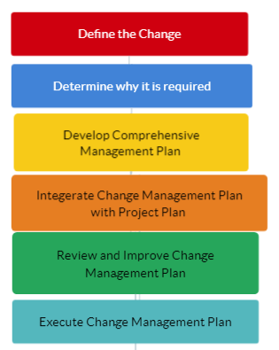

Acceptance Procedure

Acceptance of the product should be based on the acceptance criteria of all the stakeholders. Each deliverable will be reviewed and presented to the Stakeholders.

## 5.4 Quality management

Quality and Configuration Management will be done to ensure quality control and quality standards. This will be done by having quality reviews. So, all the members should review each other’s work. The team will keep eye on deadlines.

# 6       Project planning

The project has been planned to continue in a total of 18 Weeks, starting from September 2020 and finishing in January. The project planning consists of a Gantt chart, which plots the project activities on a high level alongside with several project significant events. The activities are represented by grey blocks for the percentage finished and blue blocks for the percentage unfinished.

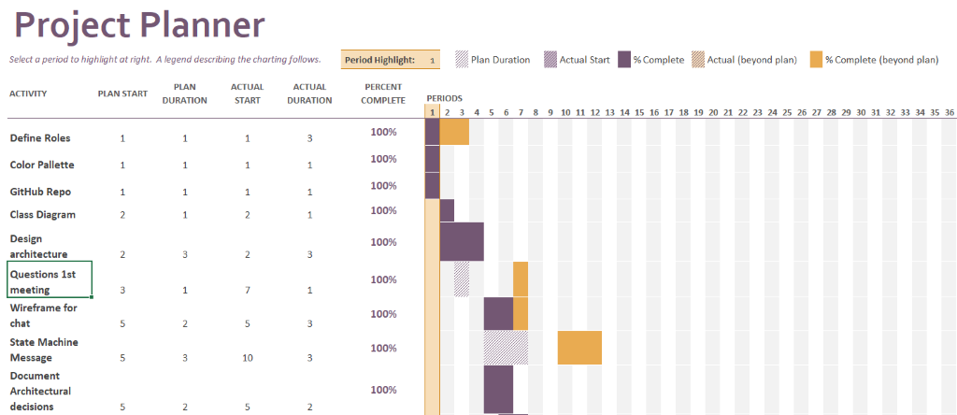

*Figure 4 Chant chart*

## 6.1 Activities

The project activities mentioned in the project planning lead to a certain project milestone. The milestones are project achievements with a high importance. The activities are plotted in a chronological way and the width of every block represents the required time for the accomplishment of that activity. It has to be mentioned that they are on a very high level and one of them consist of multiple tasks that fit into a Sprint.

Project Plan

The Project plan has the purpose to structure the projects relevant information and further on the serve as a contact between the parties of what is going to be delivered. Success factors, customer expectations, quality and acceptance criteria have been defined.

Software Requirement Specification

This document has the intention to list the client’s requirements. This document will serve as a checklist of the further implementation requirements and to list the use cases.

Test Plan

This plan is going to describe how we are going to test our software applications. It has the intention to test the reliability and consistency.

Implementation plan

The implementation plan will consist of the detailed steps, phases and milestones towards the successful implementation.

## 6.2 Events

The project events which are represented on the project planning are fixed in terms of timeslot and topic. There are going to be more events related to the project, like client interviews, company visits, solution test running etc. In order to stick to the Agile methodology, to which this project complies, these events are not fixed and therefore are not going to be included in the project planning.

Sprint Retrospective meeting

Sprint retrospective meeting is purely about the content of the current project’s progress which has been achieved, but also the challenges that the project group is facing. It has the intention to check if the project is going towards the correct direction and if there are any potentially crucial problems to deal with, if there is still time left for that.

EXPO event

Approaching the end of this semester there will also be an EXPO event in which we showcase our SoFa project to students from earlier years and explain how it works and which technologies we used.

Pagina-einde

# 7       Project methodology

## 7.1 Scrum/Agile

 The project methodology used during this project is SCRUM/Agile. SCRUM is an effective, flexible way to develop software with a project team. In the world of IT SCRUM has proven itself to be successful.

One of the core attributes of SCRUM is to work in autonomous teams. The SCRUM master is responsible for the SCRUM process. Every project member is involved in all stages of the SCRUM process, except creating the product backlog. The product backlog is filled by the product owner, with all the demands and tasks from the client and other stakeholders. 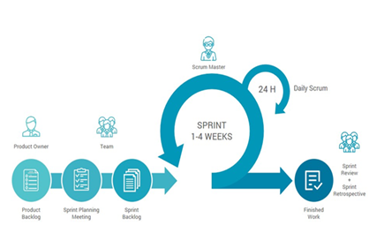

*Figure 5 SCRUM methodology*

Every sprint the project group has a sprint planning meeting together. During this meeting the team decides which tasks will be worked on in the next sprint. These tasks go into the sprint backlog. During a sprint, which takes 1-4 weeks, these tasks needs to be finished.

Every day during these sprints, there will be a daily stand up. During this stand up everybody tells what he has been doing the last day, what he is going to do today and what challenges he is facing. Because of these meetings everybody is aware of the progress, information can be shared and problems can be solved.

After each sprint the team get together for a sprint review and sprint retrospective. The goal of this sprint is to look back at the previous sprint and make a good start for the next. Important is that at the end of each sprint there must be a finished (part of a) product, which can be demoed.

## 7.2 Scrum board

One of the tools to keep an overview of the sprint planning is the SCRUM board. Every task which will be worked on during a sprint will be placed at ‘To Do’. When someone starts a task, the task moves to ‘In progress’. If the tasks are finished, it goes to testing or review. If the task has been tested/reviewed, it moves to done.

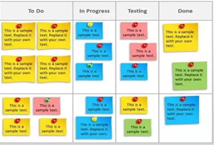

*Figure 6 SCRUM board*

The scrum board gives the team a nice overview of the process. When a team member doesn’t know what to do, he can just look at ‘To Do’ and take up a task. During this project the SCRUM board will be used through Trello.

Pagina-einde

# 8. Communication plan

## 8.1 Internal

The internal documentation will be in English. The main internal communication platform that will be used during this project is Microsoft (MS) Teams. In MS teams it is possible to chat with each other and share documents. Our sprint planning, which is updated online in Trello, is integrated in MS Teams.

Next to MS teams, we have a WhatsApp chat group for small talks. For urgent matters we can call each other.

|  |  |  |
| --- | --- | --- |
| **Name** | **E-Mail** | **Phone** |
| **Jörn Neumeyer** | j.neumeyer@student.fontys.nl | +49 1575 4837195 |
| **Tobias Jansen** | tobias.jansen@student.fontys.nl | +49 1577 1360750 |
| **Dave Hoevenaars** | [dave.hoevenaars@student.fontys.nl](mailto:dave.hoevenaars@student.fontys.nl) | +31 6 18 65 71 54 |
| **Malte Castner** | m.castner@student.fontys.nl | +49 1629 712232 |
| **Maurits van der Zee** | m.vanderzee@student.fontys.nl | +49 1763 0621317 |

Next to these communication platforms, we’ll have a daily stand-up with the project team. Our SOFA-coach is Pieter van den Hombergh. He will join the weekly project meeting on Tuesday. Besides that, he will be available to answer our questions.

|  |  |
| --- | --- |
| **Name** | **E-Mail** |
| **Pieter van den Hombergh** | p.vandenhombergh@fontys.nl |

## 8.2 External

The external communication will mainly be by E-mail. Our main contact person from Gedak Gmbh is Gerhard Bongardt. There will be meetings with Gerhard after each sprint and additional meetings when necessary. If there are any questions, Gerhard will forward the questions to the project manager.

|  |  |
| --- | --- |
| **Name** | **E-Mail** |
| **Gerhard Bongardt** | gbongardt@gedak.de |